Anthony LaRosa

DSC640 - Week 4.3

Professor Schneider

02/07/21

# Airline Safety Blog Post Supporting Documentation

In my previous submissions, I had discussed the importance and various supporting evidence for the safety of airlines. This milestone was about taking that data, compiling, and improving the visualizations done previously. Once that was completed, I then signed up for an account and wrote a blog post on what was analyzed and found.

The first thing I did was read Chapter 7 in our text book, and research online to see what makes a great blog post. I found that the first topic was that you should know your audience. I know that my audience may have their own opinions already on what the safest form of travel is. That is why I titled my blog post asking them a question, “Can you guess the safest form of travel?”

Last assigned the professor had provided feedback that the visualizations and content was good, but that there should be more varied graphs representing the metrics. I took two of the graphs that were duplications from the previous submission and reworked them into different visualizations. For the graphic that was all causes of death in the US from supplementary data, I made this into a funnel chart. The funnel chart I thought was good because it draws your eye down the funnel into the smallest piece of data. Even when we reach that data, airplane incidents are not on the chart. I thought that this conveys a powerful message. The other change I made to the graphics as in this sprints assignment we learned to make a bubble chart. The bubble chart helps matrix and visualization a third piece of data. I utilized this in my blog post to emphasize that the capacity of the aircraft was not impacting its safety rate.

In conclusion, it can be seen in the blog post that commercial air travel is one of the safest forms of travel. There are both airline specific and supplementary data which support these statements. I researched and integrated some of the key points to making a strong blog post. This included writing compelling headlines, knowing your audience, and adding images.

**Github Link:** [alarosa569/DSC · GitHub](https://github.com/alarosa569/DSC)

**Blog Post:** <https://alarosa569.wixsite.com/website/post/can-you-guess-the-safest-form-of-travel>

**Blog Post Content:**

Commercial air travel is not only the safest form of travel, but continues to gain in strength over the last 40 years. Even within decades it is clear through research backed by MIT that the organizations are investing their time and money to continuously improve the safety of the airlines. The study in question found that between 2008 and 2017 airline passenger fatalities fell significantly compared to the previous decade. The current statistic is one death per 7.9 million passengers in the most recent decade compared to per 1.3 million from 1988-1997.

Below we can see data which aligns with this research by graphing the sum of incidents and fatalities from 1985-2014 breaking them apart into two 15 year segments. The safety incidents is greater than 50% reduced in the second 15 year period.

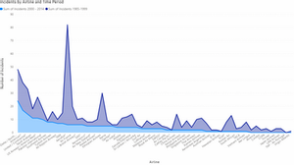

Below is now the chart but with fatalities instead of incidents.

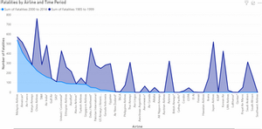

When comparing this to something most of us do on a frequent basis, driving an automobile, we can find that there is over 500 times the amount of fatalities involving the automotive industry than the commercial airline industry. We can compare the charts above to all cause of death data and find that since it does not exceed 2.6% of the collective data it doesn't even make it on to the funnel chart.

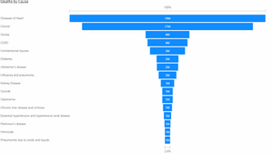

The funnel chart above can be seen to measure in millions. Below we can compare that to the fatalities in the worst time period of the 30 years measured for the airplanes and it is close to mathematically insignificant by comparison. That is quite the safety margin.

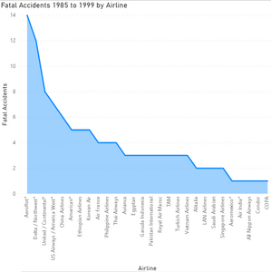

One may ask, is it because people are flying less? The next step in the analysis was to review the empty seats within the airlines. From the results, most airlines were continuing to fly with passengers and not empty.

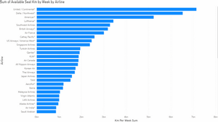

By doing a bubble chart of the available seats by airline to fatalities it can be seen that whether an airline is flying with available seats or not, they equally invested and believed in the highest level of safety for their customers.

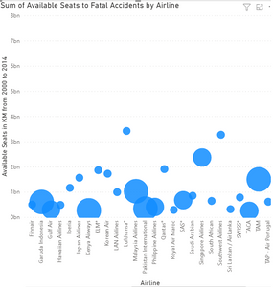

In conclusion, commercial airline travel is the safest form of travel, and is one of the lowest causes of death of all causes across the globe. The airline companies value safety. Not only do they value safety, but they ensure it is a priority for their investments whether they are flying with empty seats or have a full booking. This can assure the individuals interested in flying that they are safe and well taken care of during their travels.

**Citation**

Cederholm, T. (2014, September 03). Why political and legal factors impact the airline industry. Retrieved January 10, 2021, from <https://marketrealist.com/2014/09/why-political-and-legal-factors-impact-airline-industry/>

Datopian. (n.d.). Motor Vehicle Safety Data. Retrieved January 10, 2021, from https://datahub.io/JohnSnowLabs/motor-vehicle-safety-data#readme

FiveThirtyEight. (n.d.). Fivethirtyeight/data. Retrieved January 10, 2021, from <https://github.com/fivethirtyeight/data/tree/master/airline-safety>

Greve, H. (2019, March 21). Research: Why Struggling Airlines Spend More on Safety. Retrieved January 24, 2021, from https://hbr.org/2019/03/research-why-struggling-airlines-spend-more-on-safety

Massachusetts Institute of Technology. (2020, January 24). Commercial air travel is safer than ever: The rate of passenger fatalities has declined yet again in the last decade, accelerating a long-term trend. ScienceDaily. Retrieved January 10, 2021 from [www.sciencedaily.com/releases/2020/01/200124124510.htm](http://www.sciencedaily.com/releases/2020/01/200124124510.htm)